
A 10
Sreenidhi Institute of Science & Technology
(An Autonomous Institution)
Code No: 102CC17
M. TECH. I – Year II – Semester Examinations, August/September, 2011 (Regular)
MECHANICAL VIBRATION & CONDITION MONITORING (CAD/CAM)

Time: 3 Hours Max. Marks : 60

Note : No additional answer sheets will be provided.

* * * * *
Part-A (Objective Type)
Max.Marks:10

Answer all the QUESTIONS.

- The maximum amplitude and maximum acceleration of the foundation of a fan is X_{max} = 0.4 mm and x = O.6g. Determine the operating speed of the fan.

- Define Whirling speed of the shafts.
- What is a 1/3 Octave band.
- What are the contaminants present in the IC engine oils and their possible sources.
- What is meant by vibration signature of active systems.
- Explain about a method to measure random vibration data.
- A 500 kg vehicle is mounted on springs such that its static deflection is 1.5 mm. what is
the damping coefficient of a viscous damper to be added to the system is parallel with
springs such that the system is critically damped.
- What is the importance of Holzer's method.
- What is meant by orthogonality of Normal modes.
10. What is Gaussian random process and why is it frequently used in vibration analyzers

Part – B (Subjective Type)
Max. Marks: 50
Answer any Five. All questions carry equal marks.

1. Derive the equation of motion and find the natural frequency of vibration of the system given in figure below.
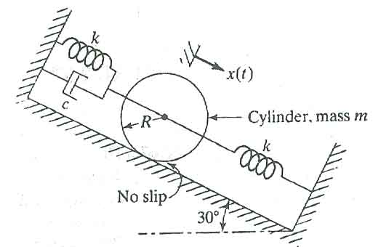
M
2. In the figure given below, a periodic force F(t) = F₀ cosωt is applied at a point on the spring that is located at a distance of 25% of its length from the fixed support. Assuming that c = 0 find the steady state response of the mass m.
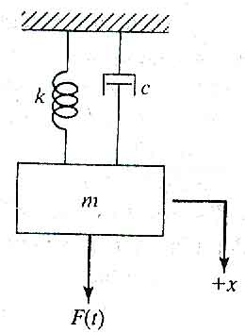

3. Three freight cars are coupled by two springs as given in figure below, find the natural frequencies and mode shapes of the system for m₁=m₂=m and k₁=k₃=k. Assume that m₃ is very very large compared to other masses in the system.

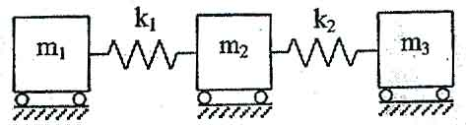

4. Derive the frequency equation for longitudinal vibration of the system shown in the figure below.
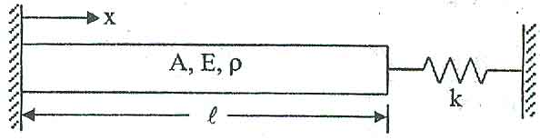

5. What are the various display and recording instruments used in vibration analysis and explain with neat sketches.

6. Explain with neat sketches experimental analysis to be carried out for identifying contaminants present in bearing oils.

7. a) A single degree of freedom system with natural frequency 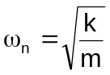 and damping ratio ξ = 0.40 is excited by a force.

F(t) = FCos ω_{n}t.
Determine the dynamic response of the system. [ 5 ]

b) Briefly explain active vibration control with at least one example. [ 5 ]
-- 00 -- 00 --

